Carla Bisong Biography

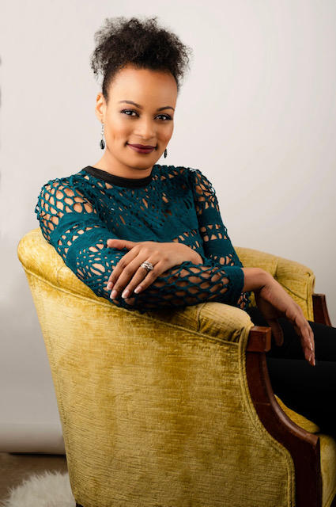

Carla Bisong, owner of Bisong Art Gallery is a fine art dealer located in downtown Houston's Historic Warehouse District. Founded in December of 2012, Carla has always had a passion for the arts. She earned a bachelor’s degree in Finance and Marketing but pursued art externally as a well needed balance. Born in Detroit Michigan and migrated to Houston Texas as a young girl with her family in the early 1980s. From 2007 to 2013, she worked for Merrill Lynch Commodities on the trading floor as business support and executive assistant.

While working in corporate America she never lost her zeal for the arts and recalls being enchanted by surrealist artists and feeling frozen in the beauty of Old World and New World Masters. If Carla can help others experience the same intensity she feels from art than her mission is accomplished.

Operating an art gallery in Houston Texas has allowed her to place beautiful & unique original artwork in the homes of collectors, small businesses and large organizations. Artist affiliated with Bisong Art Gallery have participated in public art displays and murals locally and internationally.

Carla is currently the treasurer of the Houston Art Gallery Association (HAGA) and received the MStar Diamond & Pearl Award for Community Engagement.

